10] Views :
1. Creating Views (with and without check option)∙
2. Selecting from a view∙
3. Dropping views∙
========================================================================
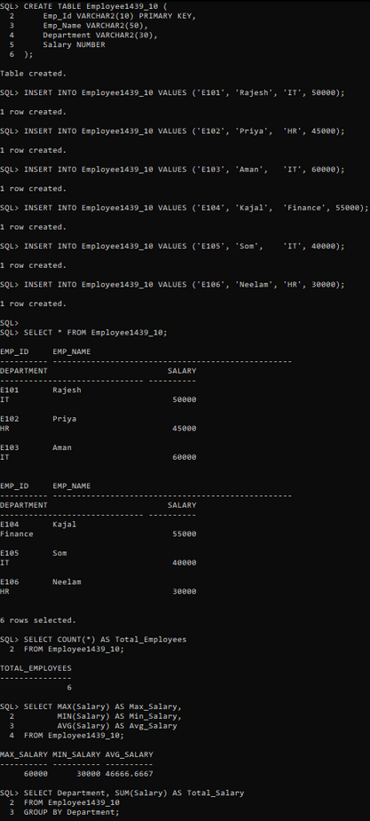
OUTPUT:

